

19P0012 AITZAZ TAHIR CH

DATA BASE LAB 07 SIR MUHAMMAD USMAN



**Ex** **7.1:**

<?php

$input = "1,2,3,4,5,6,7";

$sum = 0;

$num = explode(",",$input);

foreach($num as $v)

{

$sum+=$v;

}

echo "Total sum is : ".$sum."<br>";

?>

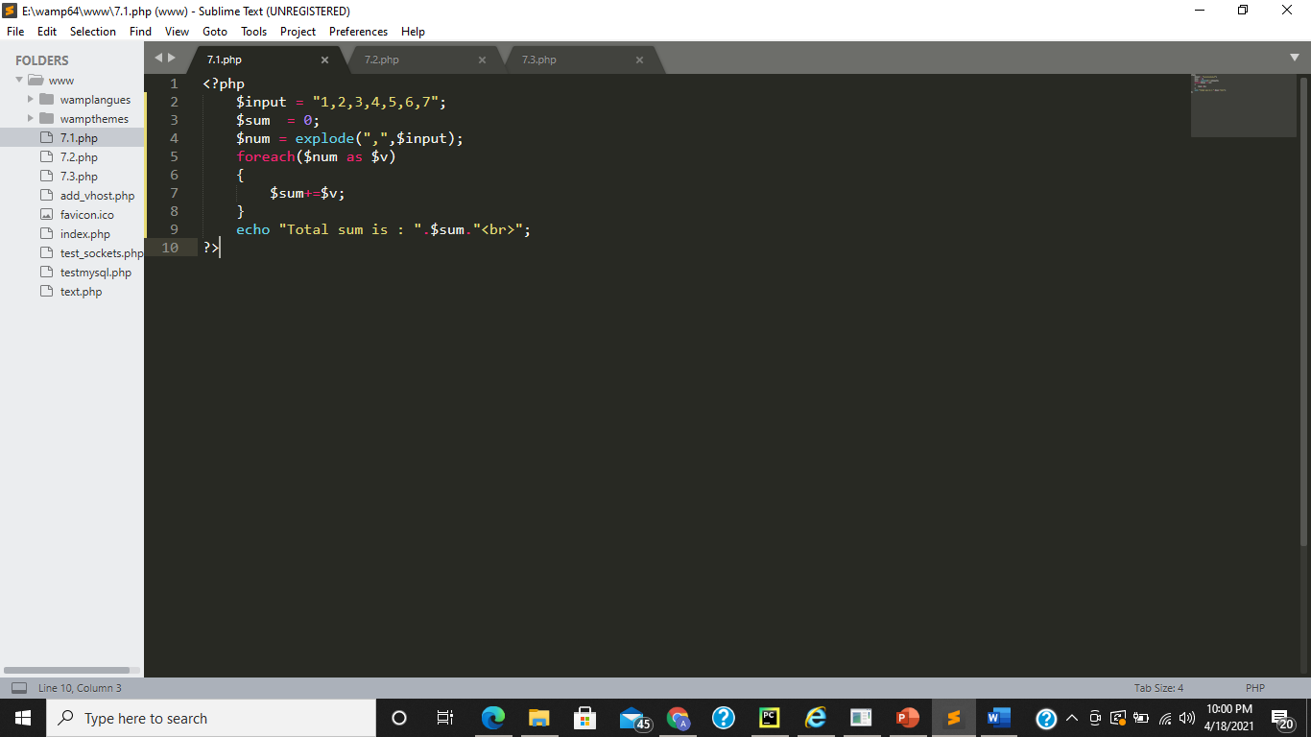

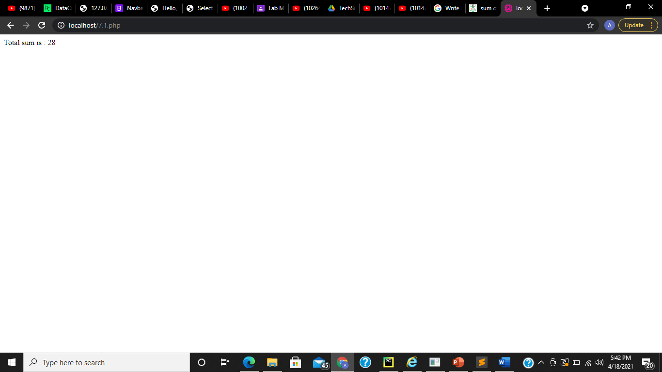

**Ex 7.2:**

<?php

$input = "A89C89";

echo "original string : ".$input."<br>";

$input = rtrim($input,"89");

echo "after removing 89 from string : ".$input."<br>";

?>

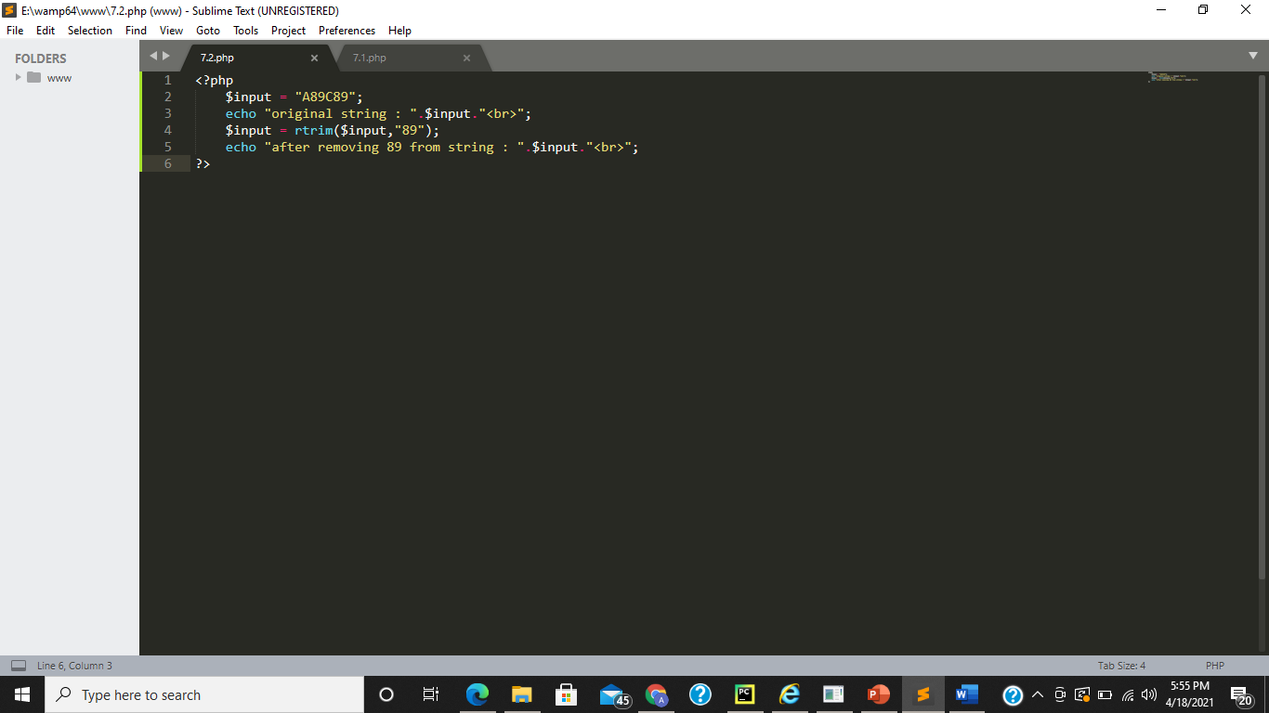

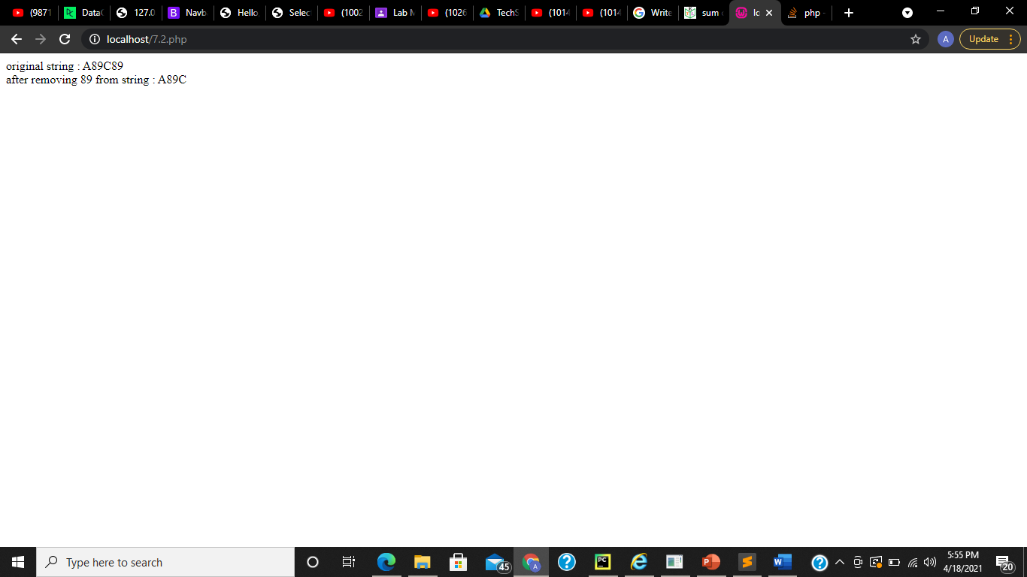

**Ex 7.3:**

<html>

<head>

<title>Theme Park Registration</title>

</head>

<body>

<?php if (isset($_POST['submitted'])){

//this code is executed when the data is submitted

$username = 'root';

$password = '';

try {

$conn = new PDO("mysql:host=localhost;dbname=themepark_lab", $username, $password);

// set the PDO error mode to exception

$conn->setAttribute(PDO::ATTR_ERRMODE, PDO::ERRMODE_EXCEPTION);

echo "Connected successfully";

} catch(PDOException $e) {

echo "Connection failed: " . $e->getMessage();

}

$query_1 = $conn->query('use themepark_lab');

$query_2 = $conn->query("INSERT INTO THEMEPARK VALUES ('$_POST[PARK_CODE]','$_POST[PARK_NAME]','$_POST[PARK_CITY]','$_POST[PARK_COUNTRY]')");

$query_3= $conn->query('SELECT * FROM THEMEPARK');

$result_1 = $query_3->fetchall(PDO::FETCH_ASSOC);

?>

<table>

<thead>

<tr>

<th>PARK_CODE</th>

<th>PARK_NAME</th>

<th>PARK_CITY</th>

<th>PARK_COUNTRY</th>

</tr>

</thead>

<tbody>

<?php

foreach ($result_1 as $key => $value) {

echo'<tr>

<td>'.$value['PARK_CODE'].'</td>

<td>'.$value['PARK_NAME'].'</td>

<td>'.$value['PARK_CITY'].'</td>

<td>'.$value['PARK_COUNTRY'].'</td>

</tr>';

}

?>

</tbody>

</table>

<p>Your data has been entered as

<?php echo $_POST['PARK_CODE'] . ' ' . $_POST['PARK_NAME'] . ' ' . $_POST['PARK_CITY'] . ' ' . $_POST['PARK_COUNTRY']; ?>

</p>

<p>Go <a href="/7.3.php">back</a> to the form</p>

<?php }

else { ?>

<h2>Theme Park Registration</h2>

<form action="7.3.php" method="POST">

PARK CODE:<input type="text" name="PARK_CODE">

PARK NAME:<input type="text" name="PARK_NAME">

<br>

PARK CITY:<input type="text" name="PARK_CITY">

PARK COUNTRY:<input type="text" name="PARK_COUNTRY">

<input type="hidden" name="submitted" value="1" />

<input type="submit" value="Submit">

</form>

<?php } ?>

</body>

</html>

